**Easy Super Detailing a 40’ Steel Boxcar**

Clinic: NMRA, MCR, Div. 4, October 14, 2022 - John Hemsath, MMR

**Materials and tools**

Undecorated boxcar: new kit (Accurail), or old car stripped of paint

<http://www.accurail.com/accurail/catalog.htm>

Metal wheelsets: Proto 2000 #21258, Tangent, Intermountain, or Kadee

Proto 2000: <https://www.walthers.com/metal-wheelsets-proto-2000-tm-33-quot-flat-back-pkg-12>

Tangent: <https://www.tangentscalemodels.com/product-category/wheelsets/>

Intermountain: <https://www.intermountain-railway.com/wheels.htm>

Kadee: <https://www.kadee.com/520-ho-scale-33-diameter-smooth-back-metal-code-110-wheels-freight-and-passenger>

Coupler lift bar: Detail Associates #6215, Tangent:

<https://www.tangentscalemodels.com/product/coupler-lift-bars-type-3-40-boxcar-5-pair/>

Couplers: Kadee #5, #58, McHenry, etc.

Roofwalk: Tichy #3077, (50’: Cal Scale #491, Kadee #2013)

<https://www.tichytraingroup.com/Shop/tabid/91/c/roofwalks/Default.aspx>

Corner grab irons: Tichy #3028 or Detail Associates # 6205

Stirrup steps: Side mounts: Tichy #3041, #3047, Detail Associates #6415

Brake gear (optional): Tichy #3013 AB Brake set add wire not included

Wire: Tichy #1106 .0125 phosphor bronze or similar

Decals: Tichy, Microscale, etc.

Laterals support: Evergreen #142 .040 x .040 strip

Screws: #2 x 3/16” self-tapping

Paint:

Primer: Tamiya, etc. (rattle can)

Color: Boxcar red, black, rail brown, roof brown, rust. Rattle can: Krylon Camo Brown, Rust-Oleum Earth Brown. Tru-Color TCP-4020 Gloss Boxcar Red.

Thinner

Clear gloss: Krylon Colormaxx gloss crystal clear (big box store)

Clear flat: Testors Dullcote (hobby shop)

Micro Sol

Weathering powder: Bragdon Weathering Powders: ($12 per set)

<https://www.bragdonent.com/weather.htm>

FF-60 light, medium, dark rust, and soot

FF-161 ash, grimy gray, dust bowl brown, and weathered brown

Tools:

Hobby knife w/ #11 blade (or scalpel with #15 blade) for slitting decals, #17 (chisel) blade to help install floor in body shell

Small scissors – cutting out decals

Q-Tips – pressing decals

Sprue cutter

Nail files: drug store, beauty supply store

#80 or #74 or your choice drill bit for stirrup steps, coupler lift bars

#42 drill for coupler box cover (clearance hole for #2 screw)

Pin vise

Small screwdriver

Air brush setup or Tru-Color Boxcar Red gloss spray paint

Side cutting pliers for wire and large sprue

Micro brush – painting wheel faces

Small brush for detail painting trucks

Toilet paper tube

Nitrile exam gloves - Costco, drugstore

Postage scale (total car weight: 3.8 ounces per NMRA RP-20.1)

Glue:

CA gel

Plastic glue

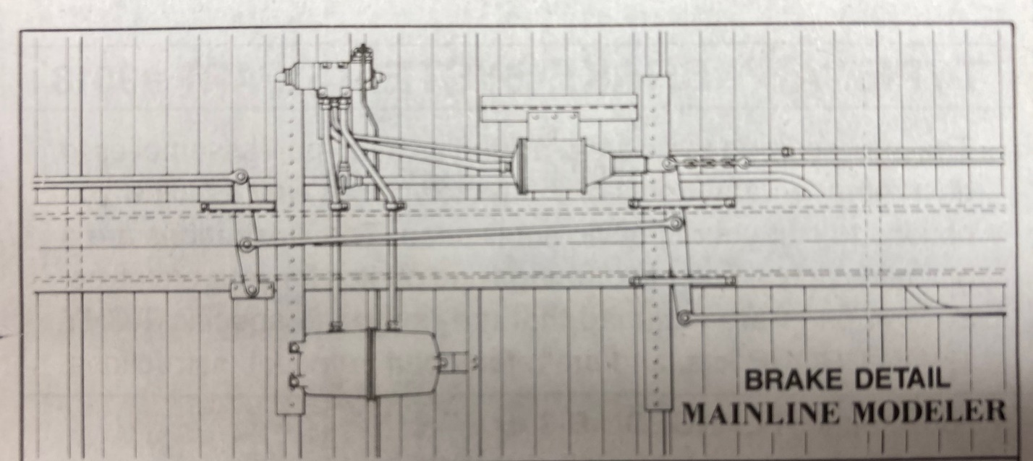

**Source links:**

Micro-Mark: <https://www.micromark.com/mini-hand-tools>

Tichy: <https://www.tichytraingroup.com/Shop/tabid/91/c/ho_freight-car-parts/Default.aspx>

Bragdon powders: <https://www.bragdonent.com/smpic/item4.htm>

Intermountain: <https://www.intermountain-railway.com/>

Kadee: <https://www.kadee.com/>

Accurail: <https://www.accurail.com/accurail/>

Tru-color: <https://trucolorpaint.com/products/>